.

**.NET Application Programming**

**Project Status and Design Report**

|  |  |  |
| --- | --- | --- |
| **Topic:** | CST-247: Milestone 3 initial Game Board Module | |
| **Date:** | 11/22/2020 | |
| **Revision:** | 1.2 | |
| **Team:** | 1. Martin Carranza | |
| 2. Nicholas Thomas | |
| 3. Brian Cantrell | |
|  | |
| **Weekly Team  Status Summary:** | |  |  |  |  | | --- | --- | --- | --- | | **User Story** | **Team Member** | **Hours Worked** | **Hours Remaining** | | Planning and task delegation | ALL MEMBERS | 0.5 H | 0 H | | Topic Research | ALL MEMBERS | 1 H | 0 H | | Game View/Model/Controller | Martin C. | 4 H | 0 H | | Product Log / Back Log | Brian C. | 1 H | 0 H | | Failed / Successful Views | Nicholas | 1 H | 0 H | | Report / Wireframes | Brian C. | 2 H | 0 H | | Razor / Views Update | Brian C. | 1 H | 0 H | | Game DAO/ Game service | Martin C. | 2 H | 0 H | | Game cell/grid DataBases | Martin C. | 1 H | 0 H | | Gameboard Model/View/Controller (first attempt) | Nicholas | 4 H | 0 H | |  |  |  |  | |  |  |  |  | |  |  |  |  | | |
| **GIT URL:** | https://github.com/The-Bakery-00/CST247CLC | |
| **Peer Review:** | Y/N | We acknowledge that our team has reviewed this Report and we agree to the approach we are all taking. |

**Planning Documentation**

**Agile Scrum Product Backlog:**

*The Product backlog is available in the Git repository:**https://github.com/The-Bakery-00/CST247CLC*

*The document is located within the* [*PlanningDesign*](https://github.com/MrAizakku/CST247CLC/tree/main/PlanningDesign) *folder.*

**Agile Scrum Burn Down Chart:**

*The SCRUM burn down chart is available in the Git repository:**https://github.com/The-Bakery-00/CST247CLC*

*The document is located within the* [*PlanningDesign*](https://github.com/MrAizakku/CST247CLC/tree/main/PlanningDesign) *folder.*

**Agile Retrospective Results:**

*The following table should be completed after each Retrospective on Things That Went Well (Keep Doing). An alternative to the following table is to use a Mind Mapping tool such as Coggle. If you use a Mind Mapping tool you must include a URL or Image File.*

|  |
| --- |
| **What Went Well** |
| 1. Team coordination is going well. Each teammate has been grabbing portions of the project and completing them on time. |
|  |
|  |

*The following table should be completed after each Retrospective on Things That Didn’t Go Well (Stop Doing) and What Would Be Done Differently Next Time with an Action Plan to Improve (Try Doing and Continuous Improvement). An alternative to the following table is to use a Mind Mapping tool such as Coggle. If you use a Mind Mapping tool you must include a URL or Image File.*

|  |  |  |
| --- | --- | --- |
| **What Did Not Go Well** | **Action Plan** | **Due Date** |
| Currently user is being pulled and reported as NULL, need to find bug doing this, for now overrriding user and creating one by default | Modifications to c.Session[“user”] to see why its being reported NULL | 11/22/2020 |
| N/A | N/A | N/A |
|  |  |  |

**Design Documentation**

**Install Instructions:**

*Step by step instructions for setting up your database, configuring, and deploying/installing your application. This section should also include detailed instructions for what configuration files are required by your application, what configuration settings need to be adjusted for various runtime (development or production) environments, and where the files need to be deployed to. This section should also contain detailed instructions for how to clone your application source code from BitBucket and deploy the application to an externally hosted site.*

At this stage in the program development process there is nothing to install.

**General Technical Approach:**

*You should, in words, describe your approach and design here. You should also summarize any meeting notes, brainstorming sessions, etc. that you want to retain thru the design of your project.*

During this time of development we are keeping things simple so we can focus specifically on the functionality of our project. We will move further into the UI design in the later weeks of the build process as currently we are focusing on the tasks in this week's milestone.

**Key Technical Design Decisions:**

*Any final technical design decisions, such as framework decisions, etc., should be documented here. This should list the technology/framework, its purpose in the design, and why it was chosen.*

**ER Diagram:**

*Image file of your ER database diagram.*

*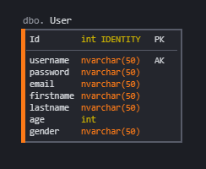 *To be changed\**

**DDL Scripts:**

*This should contain a link to BitBucket where the DDL script can be downloaded from.*

**Sitemap Diagram:**

*Image file of your Sitemap diagram.*

**Security Design:**

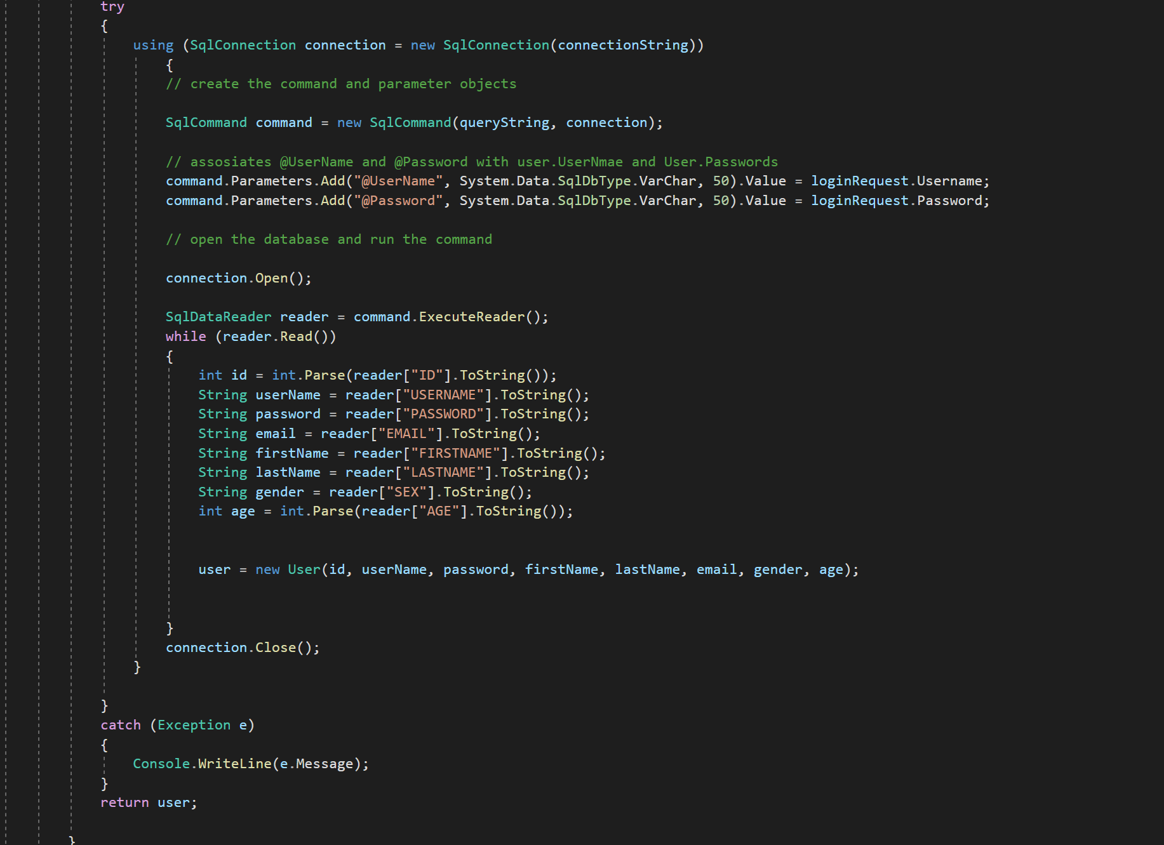

*UserDAO is used to validate login and if user is valid user wil be pulled from DB and assigned to user and returned by method. If user password and username wrong then error screen will be returned.*

**Third Party Interface Design:**

*This section should fully document any Third Party Service Interface API’s, how to access the service, what parameters are required by the API, and the detailed JSON data format specification that could be used by a third party developer to integrate with the service and API.*

**Flow Charts:**

*You should insert any flow charts here. Flow charts should document algorithms or workflow that will be implemented in your program. At a minimum this should contain a flow chart of the Minesweeper game logic.*

**User Interface Diagrams:**

*You should insert any wireframe drawings or white board concepts that were developed to support your application. If you have no supporting documentation please explain the rationale why you are able to leave this section as N/A.*

https://github.com/The-Bakery-00/CST247CLC

*The document is located within the* [*PlanningDesign*](https://github.com/MrAizakku/CST247CLC/tree/main/PlanningDesign) *folder.*

**Class Diagrams:**

*You should insert any class diagrams here. Your class diagrams should be drawn correctly with the three appropriate class compartments, + and – minus to indicate accessibility, and the data types for the state/properties as well as method arguments and return types. If you have no supporting documentation please explain the rationale why you are able to leave this section as N/A.*

**Pseudo Code:**

*You should provide BitBucket URL references to any code stubs & pseudo code. If you have no supporting documentation please explain the rationale why you are able to leave this section as N/A.*

**Other Documentation:**

*You should insert any additional drawings, storyboards, white board pictures, project schedules, tasks lists, etc. that support your approach, design, and project. If you have no supporting documentation please explain the rational why you are able to leave this section as N/A.*